Hygienic diaphragm pressure gauges,
also with ATEX version

Klingenberg, October 2018.
WIKA has expanded the application possibilities of its hygienic diaphragm pressure gauges of the PG43SA series: The model PG43SA-S is now also available in a version with ATEX approval. The pressure gauge can thus be used in hazardous areas for ignition protection type Ex h zone 1 (gas) and zone 21 (dust).

For safety-critical processes in the pharmaceutical and food industries, the model PG43SA-S and the other instruments in the series are also suitable as a result of their “dry measuring cell” (no risk of contamination by the transmission fluid), the exceptionally robust diaphragm element and the high overload protection. In addition, the model PG43SA-D is the only instrument of its kind to feature an integrated diaphragm element monitoring. This functionality is patented: A diaphragm rupture is flagged by an indicator on the dial. In the event of such a failure, a second barrier keeps the process sealed.

All hygienic pressure gauges of the PG43SA series fulfil the 3-A Sanitary Standard and are certified in accordance with EHEDG. They are CIP and SIP capable, and optionally they are also completely autoclavable.

Number of characters: 1133
Key words: PG43SA-S and -D

Manufacturer:
WIKA Alexander Wiegand SE & Co. KG
Alexander-Wiegand-Straße 30
63911 Klingenberg/Germany
Tel. +49 9372 132-5049
Fax +49 9372 132-406
vertrieb@wika.com
www.wika.de

WIKA company photograph:
Hygienic diaphragm pressure gauge:
ATEX version

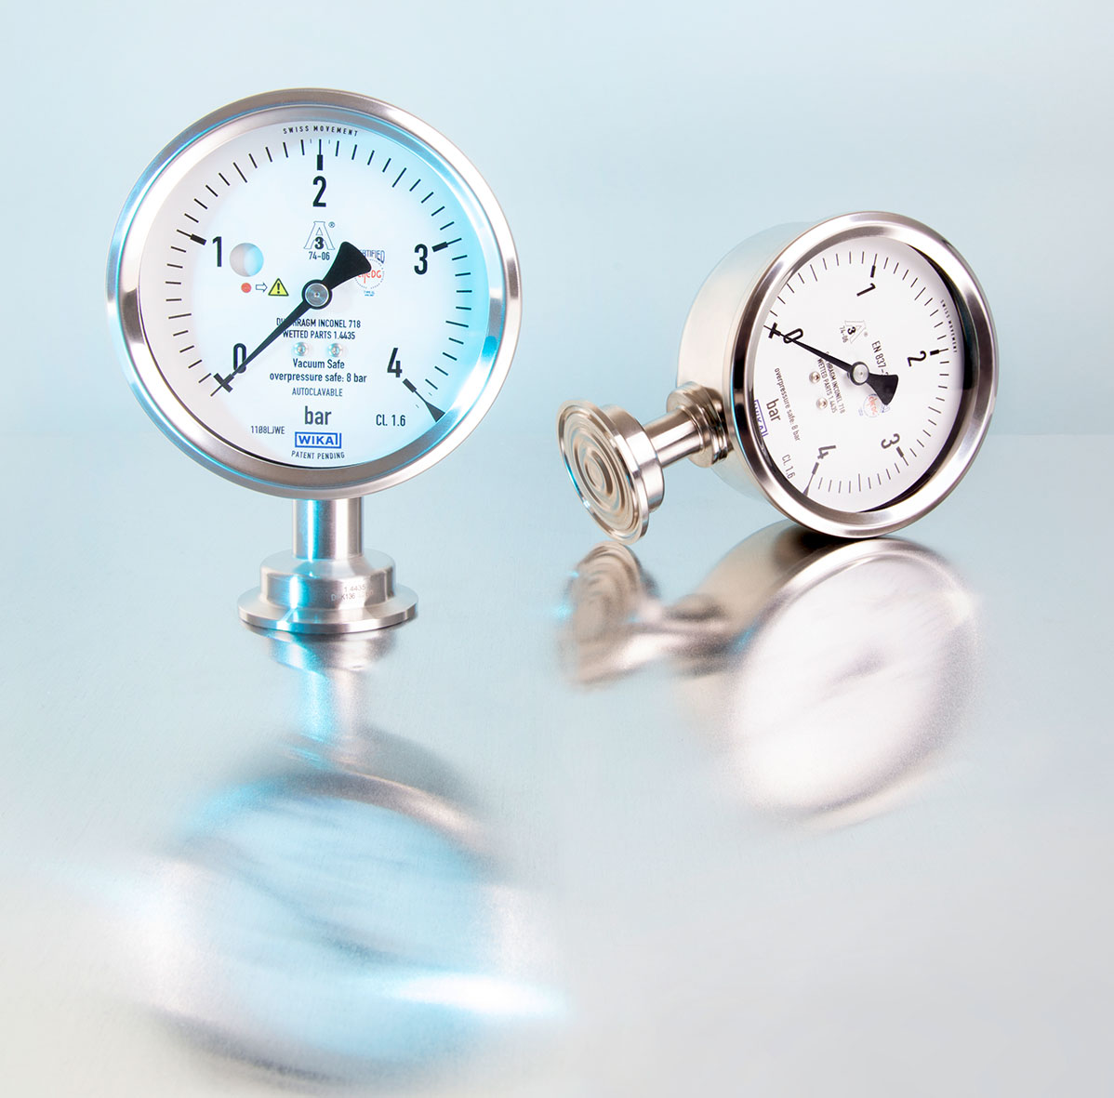

Edited by:
WIKA Alexander Wiegand SE & Co. KG
André Habel Nunes
Marketing Services
Alexander-Wiegand-Straße 30
63911 Klingenberg/Germany
Tel. +49 9372 132-8010
Fax +49 9372 132-8008010
andre.habel-nunes@wika.com
www.wika.de

WIKA press release 11/2018

