M-10 slimline pressure sensor,
now with low pressure ranges

Klingenberg, March 2017.
Due to the increasing demand for compact measuring instruments, WIKA has expanded the application range of its model M-10 pressure sensor. The exceptionally slim instrument is now also available with low pressure ranges (0 ... 6 bar and
0 ... 10 bar).

With a spanner width of only 19 mm, the instrument can be matched to almost any application with limited mounting space. The robust thin-film sensor is designed for pressures up to 1,000 bar and operates with an accuracy of ≤ ±0.5 % of span. As the model M-11, the pressure sensor is also available with a flush diaphragm and pressure ranges ≥ 0 … 25 bar. This is mainly suitable for applications with highly viscous, contaminated or crystallising media.

In order to meet the needs of OEM customers as well, WIKA has optimised the production of both pressure sensor models. The M-10 and M-11 can thus be supplied in high lot sizes at economical prices.

Number of characters: 903
Key words: M-10/M-11

Manufacturer:
WIKA Alexander Wiegand SE & Co. KG
Alexander-Wiegand-Straße 30
63911 Klingenberg/Germany
Tel. +49 9372 132-0
Fax +49 9372 132-406
vertrieb@wika.com
www.wika.de

WIKA company photograph:
Pressure sensors M-10 and M-11

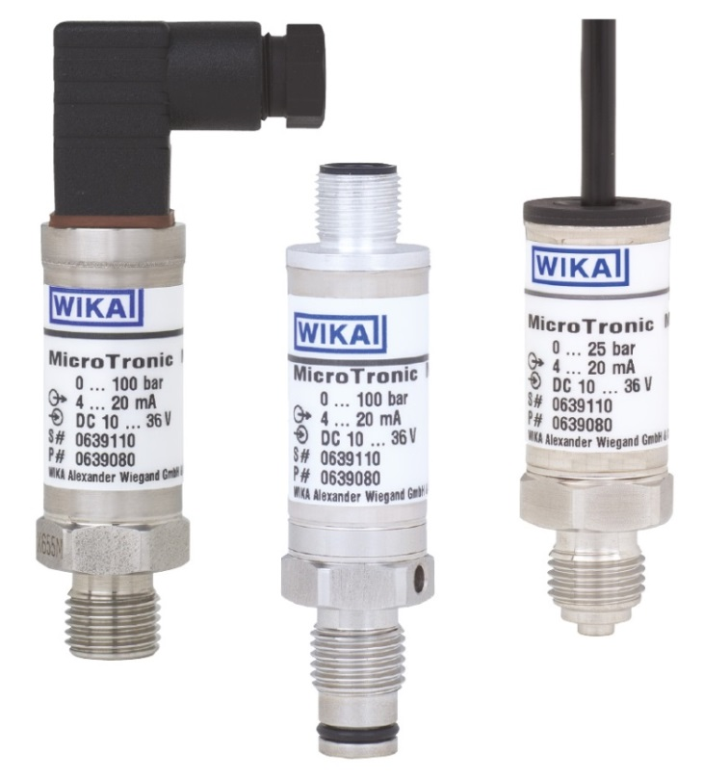

Edited by:
WIKA Alexander Wiegand SE & Co. KG
André Habel Nunes
Marketing Services
Alexander-Wiegand-Straße 30
63911 Klingenberg/Germany
Tel. +49 9372 132-8010
Fax +49 9372 132-8008010
andre.habel-nunes@wika.com
www.wika.de

WIKA press release 05/2017

